I’d rather explain it as if you were an intelligent person, which you are.

In simple terms, **control flow** is the path of actions/events that happen in your program. In the simplest case, the path is **linear**(one statement is executed after another in the order that they appear in the source code). The code on the left creates the control flow you see on the right.

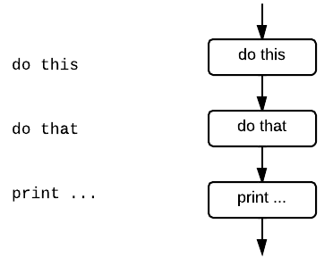

if...elif...else statements introduce **branches** in the **control flow**.

Let a, b, and c be **conditions** (Boolean expressions that can be either True or False, such as x < 3). Then an if...elsemakes a branch:

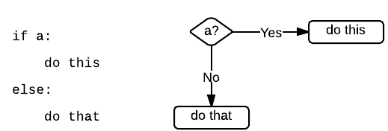

The program will *only* do this if a is True, and do thatinstead if a is False.

Each elif lets you introduce another branch:

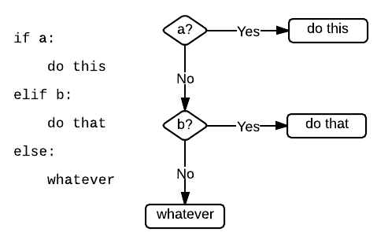

The important thing to note here is that, in order to get to do that, not only b has to be True, but a has to be False. And that’s the difference between an if...elif...else and a series of ifs:

if a:

do this

elif b:

do that

elif c:

do something else

else:

print "none of the above"

is **equivalent to** (exactly the same as) this:

if a:

do this

if (not a) and b:

do that

if (not a) and (not b) and c:

do something else

if (not a) and (not b) and (not c):

print "none of the above"

As you can see, the elif...else notation allows you to write the same logic (the same control flow) without repeating the acondition over and over again.